**Student Questions**

Learn about the internals of a standard PC case by examining physical samples and selecting and labeling images found on-line. Gain deeper knowledge by researching and reporting on specific components.

PC Tower Case

1. Find one (or more) images that clearly show the internals of a PC Tower Case.   
   (i.e. Google images using keywords “PC Case Internals”)
2. Clearly label the following components (using arrows) on your image of the PC case internals:
   1. Motherboard
   2. Power Supply
   3. Hard Disk Drive
   4. Optical Disk Drive (e.g.DVD) 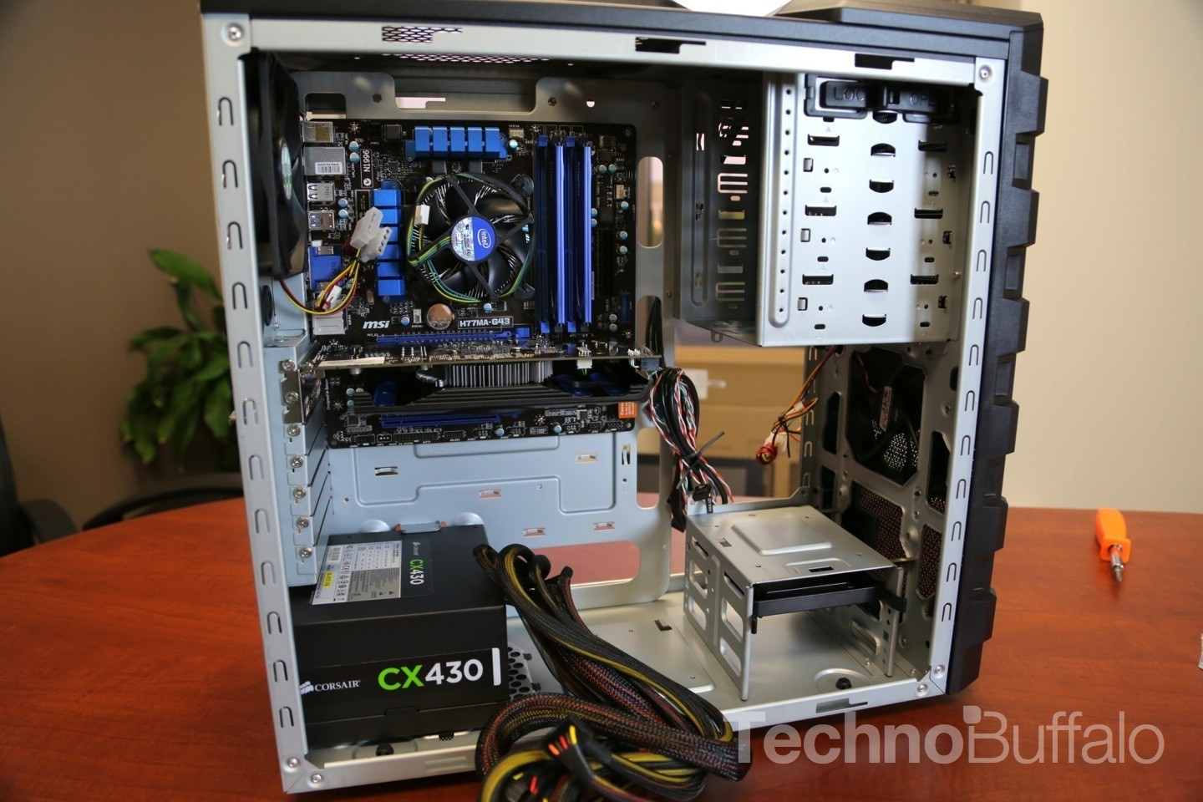
   5. USB Expansion Ports
   6. Monitor Port
   7. Audio Ports
   8. Ethernet Port
   9. Cooling Fan
3. Research more in-depth about “Hard Disk Drives”. Make notes on the following:
   1. What different versions are currently available (speed and capacity)- hard disk drive (HDD) 1TB 5400RPM spindle speed. External Hard Drive (EHD) Plus 4TB
   2. How the capacity of the component has changed since the 1980’s  
      (The first one of its kind was the RMAC. It stands for “Random Access Method of Accounting and Control.” It can store system was IBM 350. The size of the RMAC is about one canoe. The RMAC was so big it can fill up a whole room.)

PC Motherboard

1. Find one (or more) images that clearly show the layout of a PC Motherboard.   
   (i.e. Google images using keywords “PC Motherboard”)  
   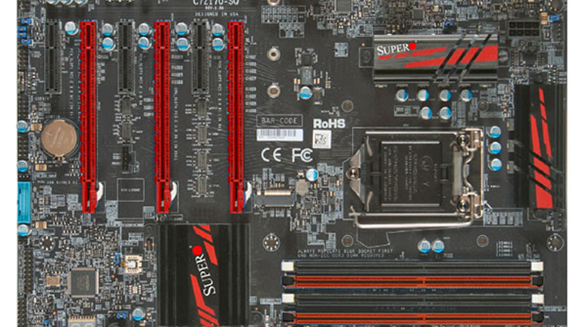
2. Clearly label the following components (using arrows) on your image of the PC motherboard:
   1. CPU (and fan)
   2. RAM Memory
   3. Disk Drive Interface (IDE or SATA)
   4. GPU Graphics Processor (either on-board or Graphics Card)
   5. Sound Processor (either on-board or Sound Card)
   6. Wi-Fi / Ethernet Network Interface (either on-board or Graphics Card)

1. Research more in-depth about “CPU Processor Chip”. Make notes on the following:
2. What different versions are currently available (speed and capacity)

(AMD Ryzen 9 3900X 4.6 GHz, Intel Core i9-9900KS 3.6 GHz)

1. How the speed of the component has changed since the 1980’s  
   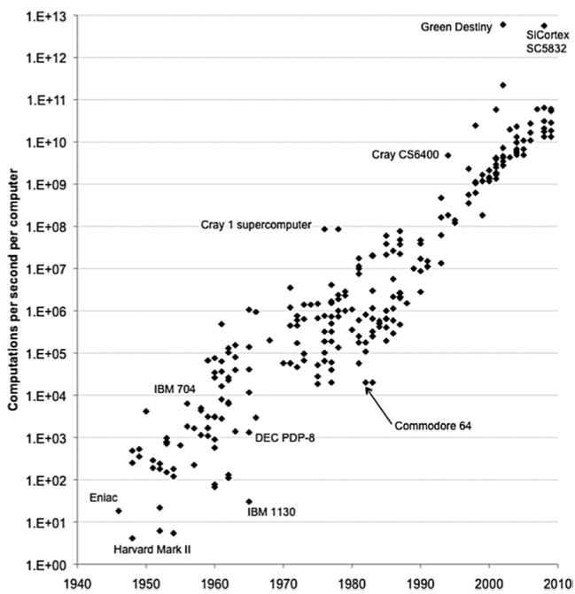

(The chart shows how fast we are moving in terms of making better and newer computer components.)

Peripheral Devices

1. Find one (or more) images that clearly show the layout of the back of a typical PC tower case.   
   (i.e. Google images using keywords “Back Of PC Tower”)  
   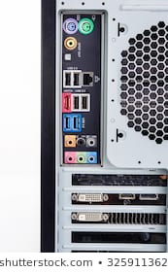
2. Clearly label the following components (using arrows) on your image of the back of a typical PC tower case:
   1. Power cord and power switch
   2. Monitor Interface (VGA or DVI or HDMI)
   3. Mouse Interface (USB or PS/2)
   4. Keyboard Interface (USB or PS/2)
   5. USB Ports
   6. Audio Inputs / Outputs
   7. Ethernet Interface

1. Research more in-depth about “External Portable Storage”. Make notes on the following:
2. Floppy Disks (The floppy disk (or a 3 1/2 floppy for today's standard) is a removable magnetic storage medium. Floppy disks are used for moving information between computers, laptops or other devices. Some early digital cameras, electronic music instruments and older computer game consoles use floppy disks.)
3. CD-ROM / DVD / Recordable CD/DVD (Compact Disc. These hold about 700MB of data. A CD drive can only read or write CDs. DVD-: Digital Video Disc or Digital Versatile Disc. They usually hold about 4.7GB.
4. USB Memory Drives (A USB flash drive is a data storage device that includes flash memory with an integrated USB interface.)
5. Compact Flash Memory (CompactFlash (CF) is a flash memory mass storage device used mainly in portable electronic devices.
6. Cloud Based Storage (Cloud storage is a service model in which data is maintained, managed, backed up remotely and made available to users over a network typically the Internet.)

**Presentation Outline**

Explore the development and features of a specific PC hardware component through deeper research and investigation. Work in partners to create a short presentation. Deliver the presentation to the class.

Each group will research a unique PC hardware component. Your specific topic will be assigned from the list provided below.

**Presentation Structure**

1. Explain what the PC component does and how it fits together with other components to make up a fully functioning PC.
2. Explain how the PC component works. Provide a diagram (image) showing the main parts of the component.
3. Research the current state of the art of the component in terms speed, capacity (size), and other related factors.
4. Research on-line suppliers that sell the PC Component. List the specifications for the available products and the cost (price).
5. Research how the PC component has changed and evolved since the early days of PCs in the 1980’s. Cover each of the following topics separately:
   1. Component Speed
   2. Component Size / Capacity
   3. Two other specifications specific to the PC component (ask Mr. Nestor)

**PC Component Topics**

|  |  |  |
| --- | --- | --- |
| **Topic** | **Partner 1** | **Partner 2** |
| CPU Microprocessor Chip |  |  |
| Motherboard Layout |  |  |
| Computer Graphics |  |  |
| Sound & Audio |  |  |
| Hard Disk Drives |  |  |
| Removable Disk Storage |  |  |
| Ethernet / Fiber Connectivity |  |  |
| Wifi / Bluetooth Connectivity |  |  |
| Mouse / Pointing Devices |  |  |
| Monitor & Display Technology |  |  |
| Printers & Output Technology |  |  |